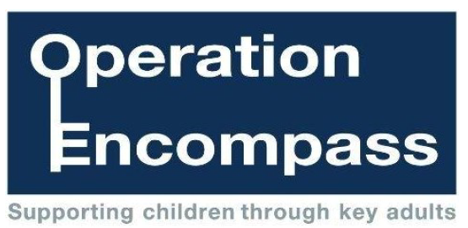

September 2018
Dear Parent/Carer
Our school has been given the opportunity to take part in a new project that will run in partnership between Cumbria County Council, Cumbria’s Local Children’s Safeguarding Hub, and Cumbria Police.
The project, Operation Encompass, has been designed to provide early reporting to schools of any domestic abuse incidents that occur outside of school hours and might have an impact on a child attending school the following day. The information will be shared on school days during the school term and, when incidents occur over the weekend, Sandra Glassford, the Operation Encompass Designated Officer, will contact the relevant school at the earliest opportunity after the information has been shared by the police.
A nominated member of school staff, known as a Key Adult, has been trained to liaise with Sandra Glassford. School staff will be able to use information that has been shared with them, in confidence, to ensure that the school is able to make provision for possible difficulties experienced by children or their families. Information will be shared, on a needs-to-know basis only, where it is identified that a child or young person was present, witnessed, or was involved in a domestic abuse incident.
Operation Encompass was introduced in Plymouth, Devon and Cornwall, in February 2011 and has proved to be very effective in providing appropriate support in a timely manner. If you would like to read more about the project in other areas of the country, this can be viewed online.
We are keen to offer the best possible responses for all children across Cumbria, and believe that Operation Encompass is going to be beneficial and supportive for all those involved.
Yours sincerely

